Robert Gabriel

R00102430 | wEB 2

Section 1

VISUAL dESIGN

Table of Contents

Welcome to my Blog 2

Typography for Display 3

Tone of Voice 6

Grids 7

Colors 9

Imagery 12

Content 13

Hierarchy of Information 15

Note

Hi Aoife, Thank you very much for teaching me as I really enjoyed this class.

I leant a lot about different designs ad what and when to use them.

Sorry if any of the spelling or grammar is off as I’m dyslexic but I went through it and got my software to as well ☺.

Anyway I couldn’t get my blog to work with the pdf creator so I copied and pasted it into word.

These are the ones in the list we studied and you told us to do the ones we studied ☺

The blog can be found on <http://www.r00102430.blogspot.ie>

# Welcome to my Blog

[](http://1.bp.blogspot.com/-7cLZqDbis5U/Ul7B7dkGnFI/AAAAAAAAAfs/ntS-3goN73k/s1600/4.png)This is my blog, for the class Visual Design and together we will travel to the world of design .All tasks can be found under the labels.

Let's Go.

# Typography for Display

## **Starbucks**

Overview:

[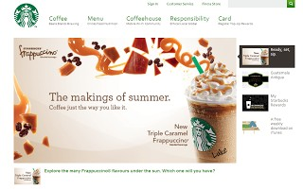](http://1.bp.blogspot.com/-_Q9wCjrHS8Q/Ul8GbMdsB_I/AAAAAAAAAgo/XDXigVqiijE/s1600/Starbuck.PNG)The Starbuck is a company famous worldwide for their trendy coffee.

Starbucks serves hot and cold beverages, whole-bean coffee, micro ground instant coffee, full-leaf teas, pastries, and snacks.

The Font:

Starbuck's uses the font veranda on their website to showcase their menu and to portray their messages across the website. As they are showcasing their coffees first and foremost.  The display default font is more for reading what they have to offer.  
At present in their slideshow, the text is there very present but doesn't take away from the images of the coffee that is inviting.  
With the font its readable, inviting, gets the message of a coffee first company.  
The Verdana font was designed to be readable at small sizes on a computer screen.  
The font is thin, well-spaced.  
PS I would say is a web safe font.

The Message: Friendly, Easy to read and trendy.

Tone: Hipsters (Not sure if a word), trendy and straight to the point where the text is easy to read, coffee coming first.  
Details: readable at small sizes on a computer screen

Font: Verdana

Costa Coffee

[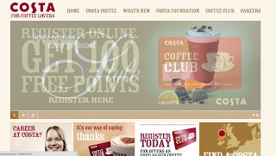](http://3.bp.blogspot.com/-vI9covIDRNY/Ul8GeDpZISI/AAAAAAAAAgw/D13dPxH2b0s/s1600/costa.PNG)Overview:

Costa Coffee is a coffee company founded by Italian born brothers Bruno and Sergio Costa. Costa Coffee is known throughout Europe and has been running since 1971.They are also known for supplying local caterers and coffee shops with their slow-roasted blend Mocha Italia.

The Font:

The font chosen by Costa Coffee is "CostaRosewoodFillRegular". They use the font across the website, from their menu along the top, of the slide show and banners along the bottom.

The font is that of old Mexican fonts. It has a little hint and reminder of old Mexico, vintage and with a mixture of that with Italy.

This along with the fact the founders are from Italy, they are showing though this font, a long history of making coffee and being original.

The Message this font is portraying is that they have a long history of making classic coffees that everyone loves and focus on just the coffee. It's swell spaced and displays to a great idea.

The Font is close and gives a bold statement

Note: CostaRosewoodFillRegular is a modified version of the popular font Rosewood. You can see the styles pop out.

The Message: Long History of making home original Coffee.

Tone: Being all about the coffee.  
Details: Rosewood is an easy font to read

Font: CostaRosewoodFillRegular.

The differences in Short

These are two websites selling the same product.

* Costa goes for history with their font.
* Starbucks goes for readability and lets coffee comes first.

# Tone of Voice

How do you strike the right tone with web visitors? It starts with your web designer and early on establishing your understanding of common tone woods. Here’s a list of words I hear a lot that should be explained more clearly.

[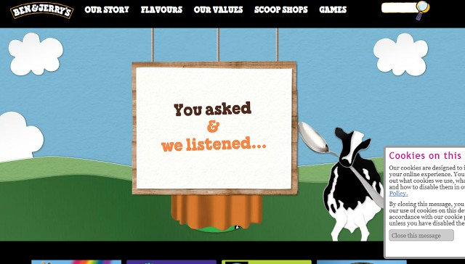](http://2.bp.blogspot.com/-tHguzKNRXek/Ung3KpC-b_I/AAAAAAAAAjg/8XFuT8erYzY/s1600/bena+nd+jerry.PNG)Let’s take a look at [Ben & Jerry’s](http://www.benjerry.com/) website

Tone of voice doesn’t work in isolation here, though. Illustrations, bright colors, a scrapbook feel, sans-serif fonts, animation and a lot of cows all support the friendly, fun and relaxed tone of voice.

Compare that to this more sophisticated and formal home page of [the White House](http://www.whitehouse.gov/):

As you’d expect, Ben and Jerry’s and the White House have very different tones of voice, but they are appropriate for what they are and fit their personalities.

[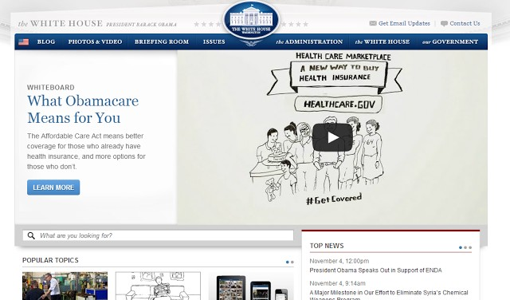](https://images-blogger-opensocial.googleusercontent.com/gadgets/proxy?url=http://2.bp.blogspot.com/-Z8Kil7sB43Y/Ung3glW11rI/AAAAAAAAAjo/yqYkkqUZx60/s640/cvb.PNG&container=blogger&gadget=a&rewriteMime=image/*)The White House’s website has a traditional color palette (a patriotic combination), a serif typeface, photography rather than illustrations, and a formal and professional tone of voice.

Ben & Jerry’s and the White House get it right. Each has found a tone that suits it and represents what it is.

# Grids

## **Grids**

Website design frameworks producing HTML and CSS had existed for a while before newer frameworks popularized the use of grid-based layouts. Some grid systems specify fixed-width elements with pixels, and some are 'fluid', meaning that they call for page element sizing to be in relative units like percentages, rather than absolute units like pixels or dots.

## **Drupal**

[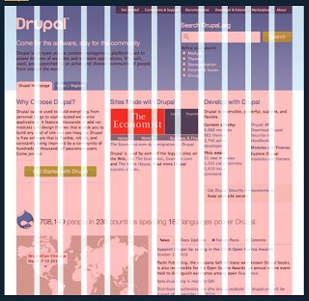](http://2.bp.blogspot.com/-pAfckQheFdY/UoKL4tQUT1I/AAAAAAAAAmo/gjd9-SjhElI/s1600/sign.PNG)The 12-column grid is divided into portions that are 60 pixels wide.

They use 3 columns across for buttons, which can be seen on the left.

They also can be seen using 6 columns across for the map system.

For major pictures or anything major takes up 3 columns across. The top half of the website (in white) is spilt into 3 columns made of four columns each. This is made in 3 sections of content. Then at the bottom near the page the section is split up into two. Also to be noted is the logo takes up one column. The search input takes 3 columns and the header text takes up 10 columns.

Onehub

The 16-column grid consists of 40 pixel increments.

[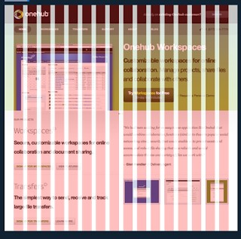](http://2.bp.blogspot.com/-FIHpDrVKue0/UoKd1XzDVQI/AAAAAAAAAnA/cXpY6yi2ml0/s1600/nd.PNG)As seem to my right the website is Onehub and they use a 16 column based grid system.

The navigation along the top and the whole site takes up the full 16 columns.

The main content of the website has been just below the navigation. It is split into two sections of two 8 columns span each (40 x 8  = 360px).

The rest of the rest below the main content area, is spilling into the same 2 , 8 column wide system. With images taking up 2 or 3 spans. The text also takes up to 6 columns.

## **Overview**

The reach I did on this showed me a lot of the different ways different grid systems and number of columns can be used in different ways. I personally loved doing this research, I liked the 16 column the best but more of that here.

# Colors

## **Crowley Solicitors**

Crowley’s Solicitors main two colors are Purple and White.

[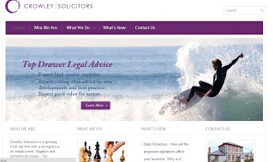](http://4.bp.blogspot.com/-d9oBT8UPoCk/UmK_7k1VfHI/AAAAAAAAAhQ/Na7ga2M6-9I/s1600/Capture.PNG)Purple is known for Purple has long represented royalty, power and wealth. Purples also promote a sense of creativity and imagination, because the color is not dominant in nature. The color purple who gives the impression and know for power and control. White is used for clarity, cleanliness and openness.

This is all great for a Solicitor who are there for years.

<http://www.crowleysolicitors.ie/>

## **Cantillons**

Canutillo’s main colors are Blue and Gold.

[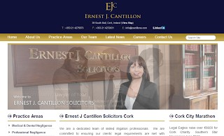](http://1.bp.blogspot.com/-N6a2_8aQeqw/UmLEHwl2B9I/AAAAAAAAAhc/eRlgua0aIXE/s1600/sss.PNG)  
Blues are the hues of serenity, peace and security. The color Blue also creates a sense of calm and friendly.

Blue works well as it's a shade that most people can relate to. Darker blues are also text friendly. Darker blues are often used in the color schemes of corporate websites.

Dark Blue is known for knowledge, power and trust. All this is a great way to show what a person wants from a Solicitor. The touches of gold give the meaning of prestige and wisdom

<http://www.cantillons.com/>

## **Final Thoughts**

As it can be seen, both websites do the same thing but are totally different when it comes to colors. That color gives off different meaning as well.

# Imagery

In this entry I will talk about my research on Imagery in design.



The pictures I found on pentagram that is perfect for this blog post is below.

To the right is a photo from a Fit Nations campaign that is to aim for a healthy lifestyle.

It shows the shape of a human with minimal effect doing exercise in simple and straight forward everyday movement.

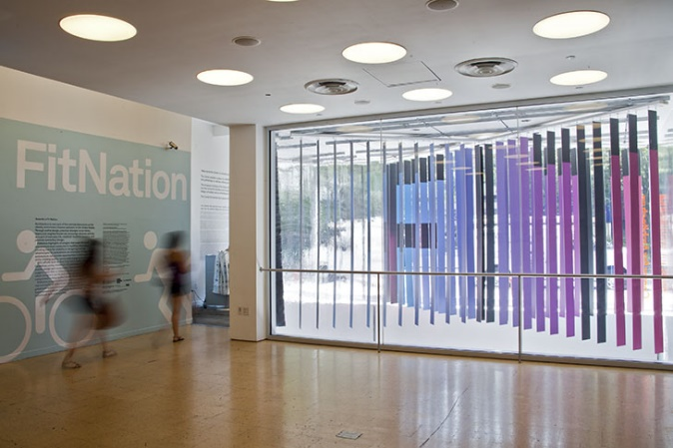

Showing taking the stairs is healthier, giving a real message. As I motioned before it tells the passer by that is possible to take action, moving up the stairs.

As seen on the right, this image shows off the use of cycling and the positioning of the front door, shows that maybe the view or passing by should think about cycling to work.

# Content

The two websites I choose to compare where

<http://www.fionadixon.com/>  and <http://www.paulogoode.com/>

[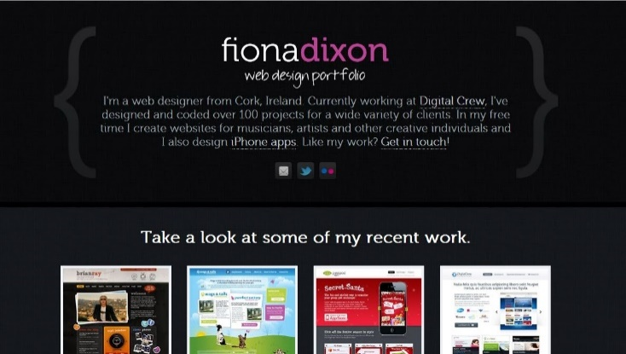](http://1.bp.blogspot.com/-plyJsvWbR-Y/UqpfDUnnnOI/AAAAAAAAAq4/XLnxRC6ocm4/s1600/Capture.JPG)  
The first website by Fiona Dixon is from her protocol website. It shows off and advertises her skills and old work she has done and services she provides. The Home page /landing page presents in a monochromatic set of colors with black/gray and its shades pink. Bigger in size and pink headings bring the user’s attention in to important information but in a descriptive manner.

The Images she uses spoken to a wide range of services and skills she can pervid and done in the past. The tone of voice describes her as a professional who is creative and can meet the client’s needs and wants.

[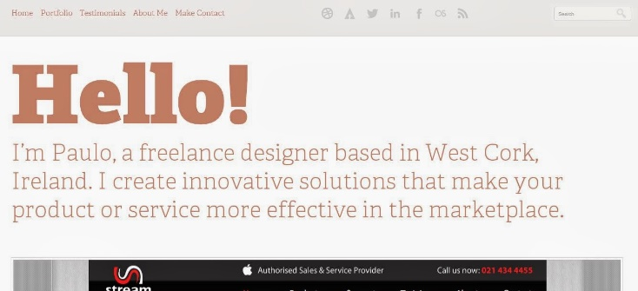](http://4.bp.blogspot.com/-538P9NycBfE/Uqpf7aCZRWI/AAAAAAAAArA/119y98akIH4/s1600/2222.JPG)The second website I picked and was a web portfolio by web designer by Paul Goode.

He uses a light gray/white background color with a flat reddish color for the font.  
The main textual content provides a short description of the person Paul good and the skills hers provide and his skills.

He uses a mix between technological speak and simple to understand launge for potential customers.

Which shows a great mix. He writes about past work and the thought he had on each project/website.

The website gives a friendly vibe to the visitor while you get to know the person Paul before you even talk to him. Cause of the text and the way he talks in his sentences. In general this web site describes web professional who knows his skills and knows his audience and customers.

# Hierarchy of Information

|  |
| --- |
|  |
|  |

[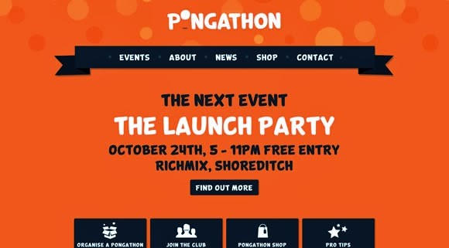](http://3.bp.blogspot.com/-lkZwquty4DA/UqmhSUf3t3I/AAAAAAAAAqA/7d5DdGiY5OI/s1600/contrast.jpg)Each design consists of many components which play important role as a part between designer's idea and the spectators. Color, layout, size, type and texture and of course white space are some of the genes responsible for the final effect, positive or negative if improperly applied.

[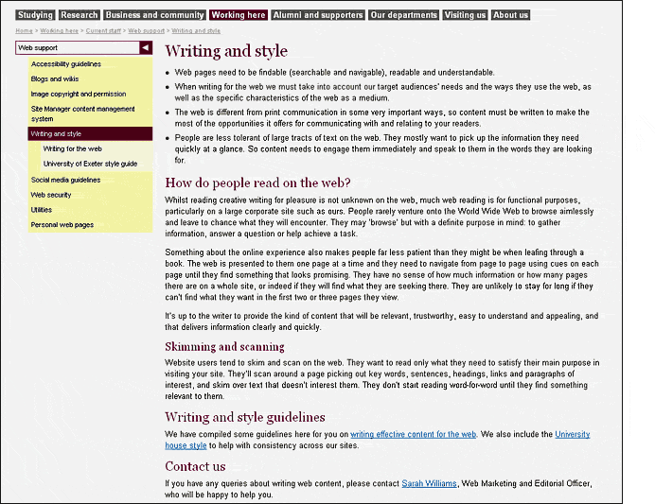](https://images-blogger-opensocial.googleusercontent.com/gadgets/proxy?url=http://1.bp.blogspot.com/-GBPl9yCWpco/UqmhwE4Kn_I/AAAAAAAAAqQ/M2GDlsxE2Nc/s1600/text.gif&container=blogger&gadget=a&rewriteMime=image/*)I came across an article during my research where our teacher Aoife quoted in a phase (seen below), in it the writer talked about what meanings that are conveyed by visual and non-visual content and how people see the links between them in different ways.

As the author stated

“Understanding that people will see our designs in terms of relationships is crucial to becoming a more efficient designer.”

All of that supported with a wide variety of examples complements the communicated message. Seen in the pictures/screenshots I have chosen you can see the differences the different types make. White space, the formatting of text and so on ☺